**PAKISTAN PRIMARY SCHOOL**

**MATHEMATICS**

**Chapter - 2:  Arithmetic Operations**

**TOPIC:  Multiplication using place value**

**Partial Products:** (2 digit x 2 digit)  
  
                                 32  
                            x   34  
                               900   (30 x 30)  
                               120   (30 x 4)  
                                 60   (2 x 30)  
                                   8   (2 x 4)  
                              1,088  
  
**Area Model:** (1 digit x 3 digit)

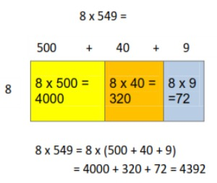

**Area Model:** (2 digit x 2 digit)

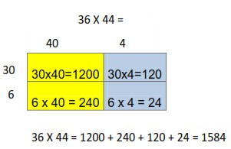

**Partial Quotients:**   7725/6  
  
                    1204 r 1  
                6) 7225  
                 - 6000 ( **1000** x 6)  
                     1225  
                   - 1200 (**200** x 6)  
                          25  
                       - 24  (**4** x 6)  
                           1

**Partition the Dividend:** Partition the dividend into  
multiples of the divisor.  
  
                 292/4  
  
                70 + 3 = 73  
           4) 280 + 12